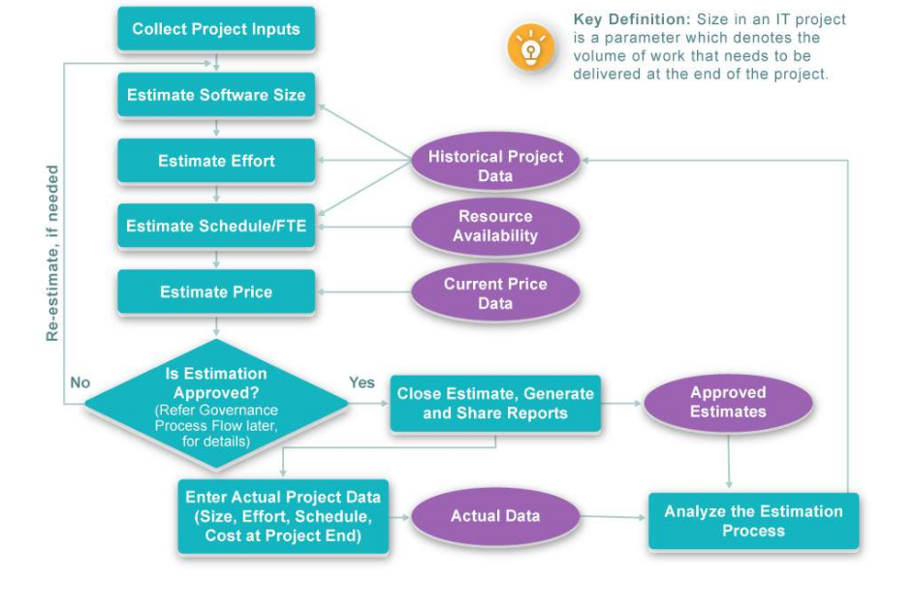

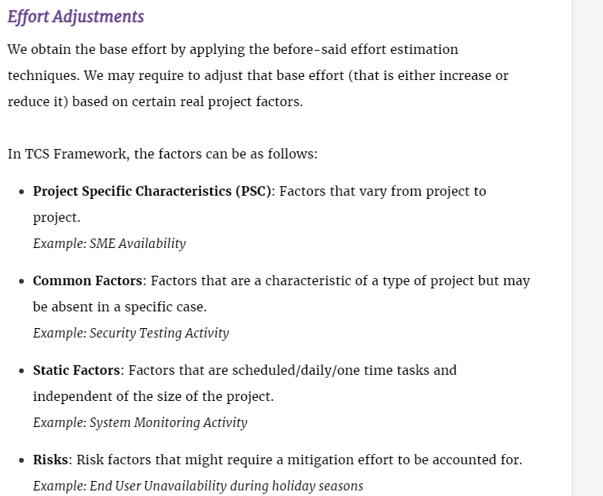

## Estimating a software

A software size is measured in function points like functionality or story points

Distance is measured in kilo metres

Water is measured in litres

Software size is measured in function points

While measuring software consider all the below points

